November 2017 Youth Group Calendar (Grades 6-12)
Sun. | Mon. | Tue. | Wed. | Thu. | Fri. | Sat.
 |  |  | 1 | 2 | 3 | 4
5 | 6 | 7 | 8 | 9 | 10 | 11
Youth Group  10:30-11:30  *daylight savings |  |  |  |  | Movie Night Out!  (movie & time tbd)
12 | 13 | 14 | 15 | 16 | 17 | 18
Youth Group
10:30-11:30
19 | 20 | 21 | 22 | 23 | 24 | 25
Youth Group  10:30-11:30 |  |  |  | Happy  Thanksgiving
26 | 27 | 28 | 29 | 30
Youth Group
10:30-11:30

Events | 11/10: Movie Night  Join us for a night out at the movies! Popcorn, snacks, and an awesome film (movie choice to be determined). We will meet at United Artists Colorado Center 9 (2000 S. Colorado Blvd). Allison will let you know about times once we pick a movie!  Youth Group  Meet us on Sundays during the 10:30 worship service in the Youth room downstairs (after the first 3 songs are sung) for fun and fellowship!  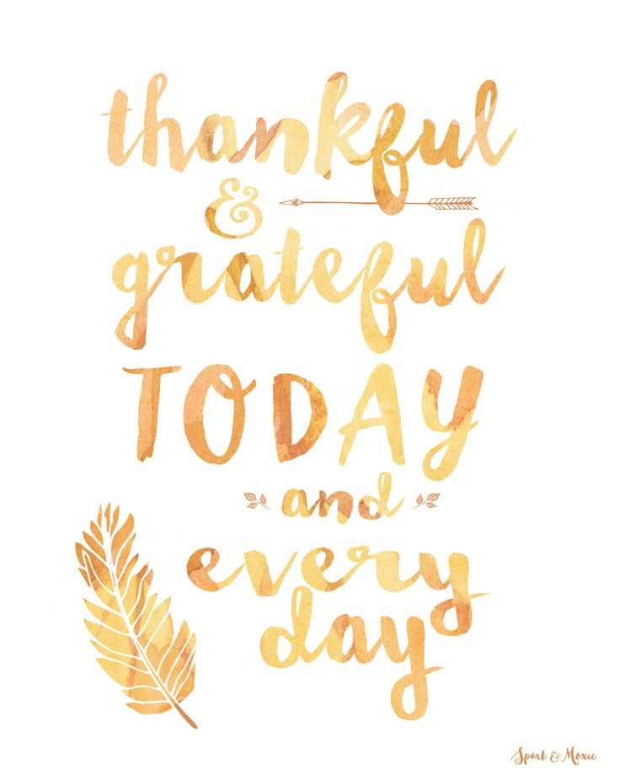
Please call Allison Motsenbocker with any questions at (610) 639-0133 or email at Allison@plattparkchurch.org

